Docker Exercise

1. Launch the docker in linux machine

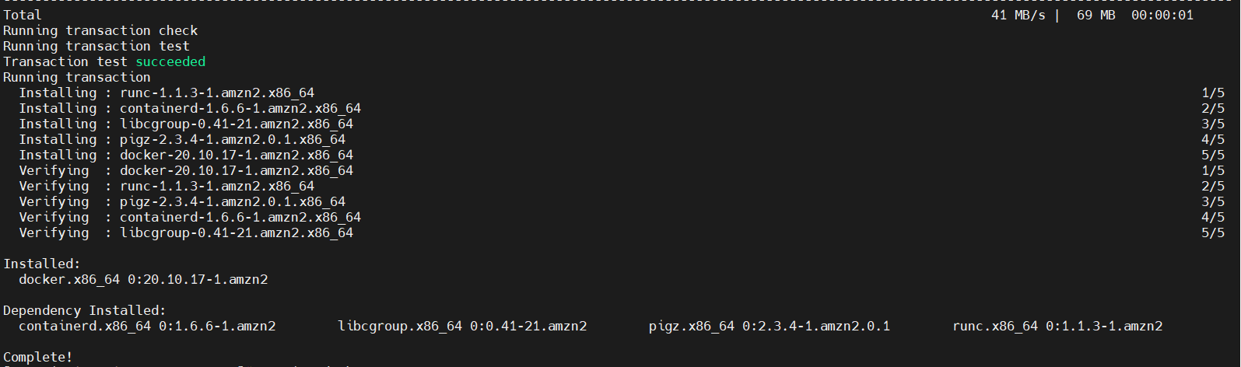

1. Create a ubuntu container.....inside that create some files...also install apache2 in that ubuntu container....Now i want you to create replicas of the container ...how will you create it? please put screeenshot wise screenshot for your personal notes

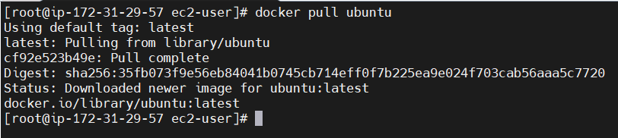



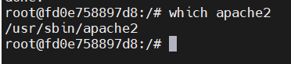

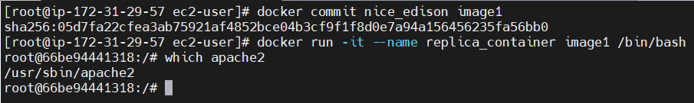

1. I want to create a shared volume (akshatvol) in ec2 which can be shared between 5 containers(c001,c002,c003,c004,c005) ....how will i do that?

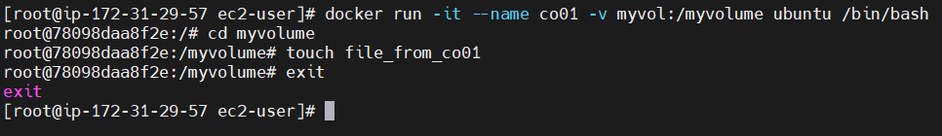

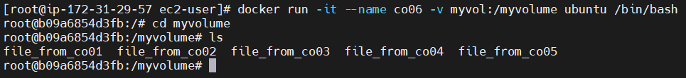

1. watch the video and perform the lab: https://www.youtube.com/watch?v=bR_uLlxlKwE&t=309s

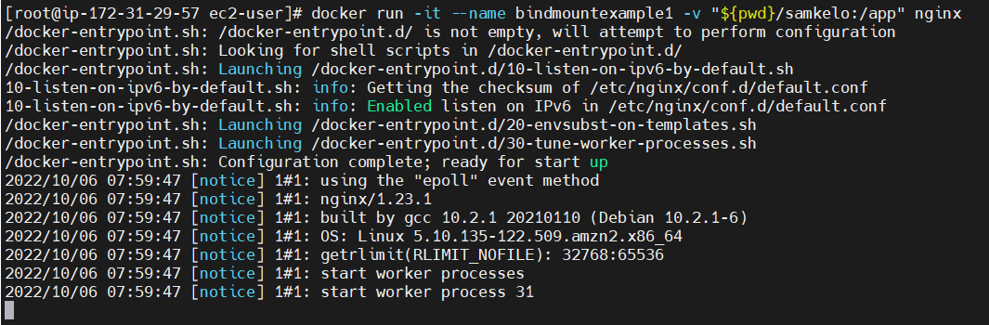

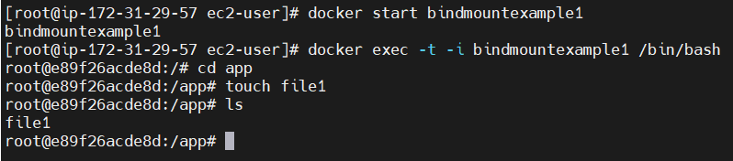

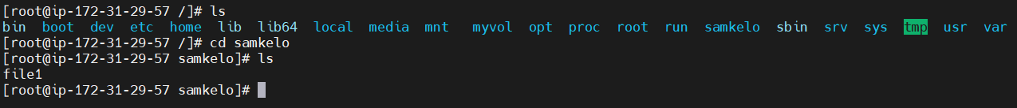

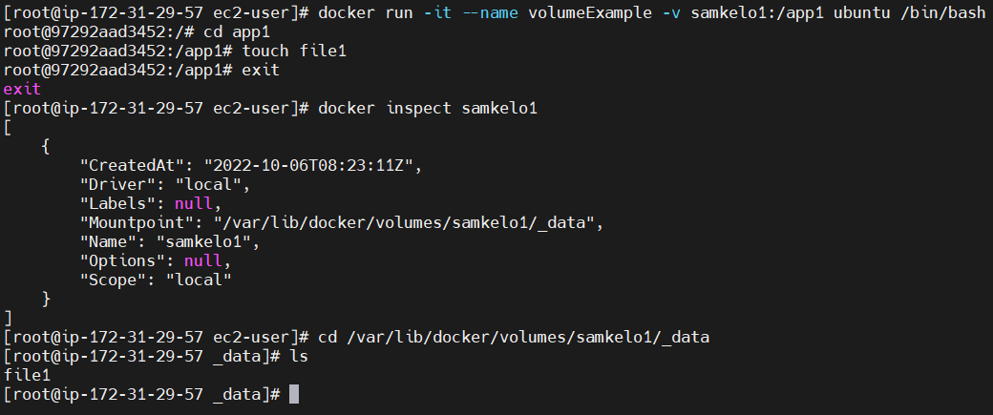

1. Perform this : https://www.youtube.com/watch?v=y2ZiT47tsm4 (not the part of devops...just to make you understand the importance of apache server and its use)

